# Garch Model

The GARCH model with normal distribution giving us the following results:

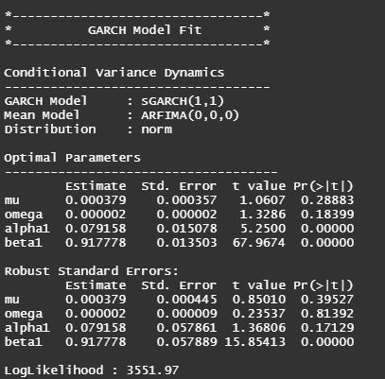

The first table of the first part of the estimation (see table named "Optimal parameters") shows the optimal estimated parameters. This table shows the significance of the estimated parameter. It shows that the constant parameter omega1 (parameter w1 in the model setting) tends to be non-significant, meaning that the constant parameter seems to be not useful in this model setting.

On the other hand, the skewed student distribution is returning the following results in which we are we are trying to get better results and a better model fit.

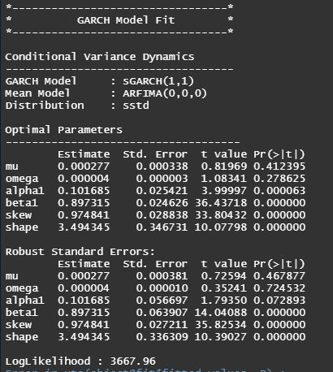

The p-values of the table of this model decreased that shows this is a good model to use. So instead of using normal distribution. We must be using skewed distribution. The following are the graphs that are determined from this.

